1.a Solution 1
1.b Solution 1
1.c Solution 2
1.d Solution 2
1.e Solution 3
1.f Solution 4

1.a Solution
For image to be viewed properly, sampling plays an important role. If the sampling rate is not high enough to capture all the details of the image, it creates aliasing. This results in strange artefacts in the image that were are not really present. For the image in the example below this effect can be clearly seen. is the original image. There are no additional circle centres because the sampling rate of the image is good enough to capture all the information correctly. When we subsample it to reduce the image dimension using , we can see additional 8 circle centres. This is because we have halved our sampling rate which resulted in higher frequencies getting indistinguishable with some of the lower frequencies. When we further reduce the dimension (), we get an image with 8 bright circle centre and 16 faint ones. This is because we have reduced the sampling rate to a third of the original value because of the we can see an even higher distorting of the higher frequencies. To counter this, before down sampling the image, we should first pass it through a low pass filter ensuring that the cut-off frequency of the filter is below half of the new sampling rate. This will ensure that the higher frequencies get supressed before down sampling, and will not interfere with the final image creating distortions.
myShrinkImageByFactorD(); % 1.a
NOTE: While using the publish feature of MATLAB, image resizing was taking place, which led moiré effect. To remove this, we had to separately save the images and then replace them in the report.
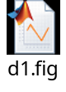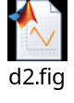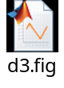

1.b Solution
Bilinear interpolation is a simple method of interpolation which assumes that the intensity value at any point inside a grid is a linear combination of the intensities at the 4 ends. This provides a simple method for predicting the value at any point inside the grid which can be used for up sampling the image. Although this provides a smooth method of up sampling, this is not the idea way to do it.
biLinearInt = myBilinearInterpolation(); % 1.b
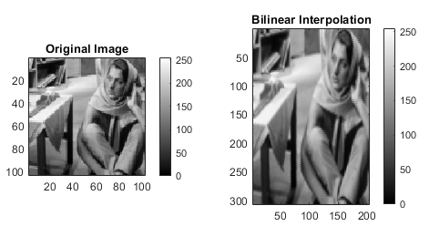

1.c Solution
Nearest neighbour interpolation is one of the simplest methods of interpolation. In this method we replicate the value of the nearest pixel for up sampling the image. Because of this, when we up sample the image, we see small box like entities in image.
nearestNeighInt = myNearestNeighborInterpolation(); % 1.c
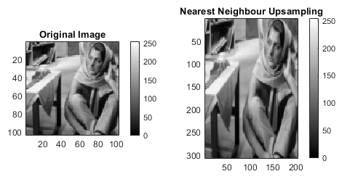

1.d Solution
Bicubic interpolation is a sophisticated method of interpolation which takes into account the smoothness over the adjacent grids. Advantage which this method provides over bilinear interpolation is that it matches the first derivative over adjacent region making the overall region smooth.
biCubicInt = myBicubicInterpolation(); % 1.d
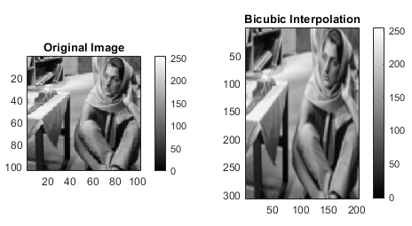

1.e Solution
Here we compare the results from 3 different methods of interpolation. 1. Bilinear Interpolation 2. Nearest Neighbour Interpolation 3. Bicubic Interpolation For this comparison, we have used a window. It can be easily observed that the image with interpolation as nearest neighbour, shows huge blocks of pixels and sudden changes of intensities. Comparing this to bilinear case, we can see that bilinear interpolation provides better transition from one shade to another. In the case of bicubic interpolation, this effect can be seen much more clearly.
Some of the area where the difference can be very clearly seen are the left side blue rows (rows pointed by red arrow) in all the 3 images. For the nearest neighbour approach, it can be clearly seen that there is slight gradient, but the smoothness of the change is not that good. For the bilinear case it can be seen that there is some variation in the blue shade. This may be because of noise. But for the bicubic interpolation it can be very clearly seen that the overall the image have smoothed and the gradient along the x direction of the image have also improved. Overall if we compare the bilinear and bicubic results, we can see that for bilinear one, there are some sudden changes in the intensities, whereas for cubic that have been smoothened out.
size = 50; startI = 200; startJ = 75;
cropLinear = biLinearInt(startI:startI+size, startJ:startJ+size);
cropNeighrestNeigh = nearestNeighInt(startI:startI+size, startJ:startJ+size);
cropBiCubic = biCubicInt(startI:startI+size, startJ:startJ+size);
figure();
imagesc(single(cropLinear)), title('Bilinear Interpolation'), ...
daspect ([1 1 1]), colormap('jet'), colorbar;
figure();
imagesc(single(cropNeighrestNeigh)), title('Nearest Neighbour'), ...
daspect ([1 1 1]), colormap('jet'), colorbar;
figure();
imagesc(single(cropBiCubic)), title('Bicubic Interpolation'), ...
daspect ([1 1 1]), colormap('jet'), colorbar;
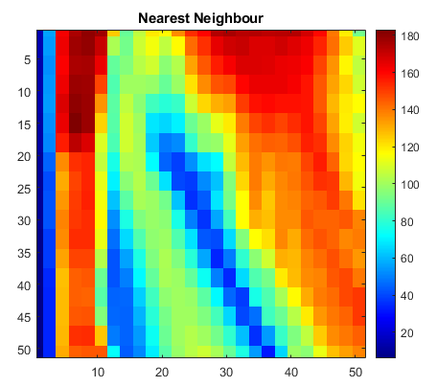
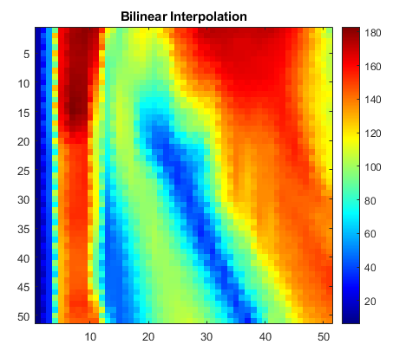
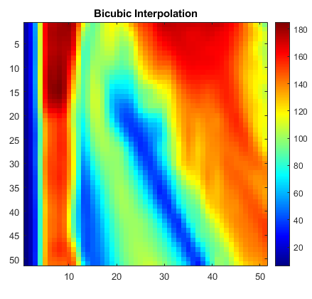

1.f Solution
For rotating an image by clockwise, it is the same as rotating the underlying grid by counter clockwise. To get the resultant image, simple bilinear interpolation was used.
myImageRotation();
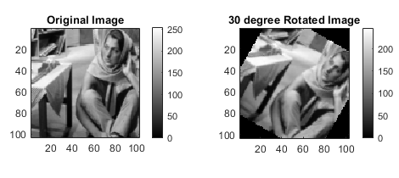
Published with MATLAB® R2020a

